**Synth Surgeons: Synthesizer User Manual**

1. **Features**

* 13 note full octave ranging from a low C to a high C each with unique frequencies
* Mode toggling that enables the user to switch between 3 waveforms: sawtooth, triangle, square
* Sound toggling that mimics the function of a soundboard equipped with 2 unique sounds
* An active-low enable that allows the synthesizer to operate only when enable is on
* An asynchronous active-low reset
* 13 note-indicating LEDs

1. **Applications**

* Wave frequency analysis
* Sound generation
* Physical demonstration and understanding of chip design

1. **Description**

The Synth Surgeons Synthesizer is a fully operational sound generation chip that allows the user to play each of the 13 notes in a middle-range octave. As an added feature, the user can change the way in which each note sounds by toggling waveforms as well as playing pre-programmed sounds, such as a sound board. Additional features include an enable and reset button.

1. **Button Layout on an FPGA**

| **Variable** | **Description** | **Location** |
| --- | --- | --- |
| keys | 13 notes ranging from a low C to a high C in one middle-range octave | pb[12:0] |
| mode | Toggles the 3 different waveforms: triangle, sawtooth, square | pb[13] |
| sound_series | Toggles the different pre-programmed sounds | pb[14] |
| en | An enable button that allows the user to play sounds while pressed | pb[18] |
| n_rst | An asynchronous reset | pb[19] |
| is_FPGA | A button that when pressed signifies whether the chip is being demonstrated on an FPGA board or not. Important due to the difference in clock frequencies. | Hardwired in code |
| pwm_o | System output for speakers | left[7] |

1. **Pin Configuration**

| **Name** | **GPIO Pin #** | **I/O** | **Description** |
| --- | --- | --- | --- |
| Clock | N/A | I | Timing component |
| Reset | N/A | I | Resets output supply when active low |
| Keys | 0:12 | I | 13 buttons assigned to each of the 13 notes in one middle-range octave |
| Mode | 13 | I | 1 button that toggles 3 waveforms |
| Sound_series | 14 | I | 1 button that toggles 2 pre-programmed sounds |
| Pwm_o | 15 | O | System output that connects to speakers |
| LED | 16:28 | O | Note-indicating LED |

**Total I/O Pins: 29**

**Register Transfer Level Diagram: Top Level**

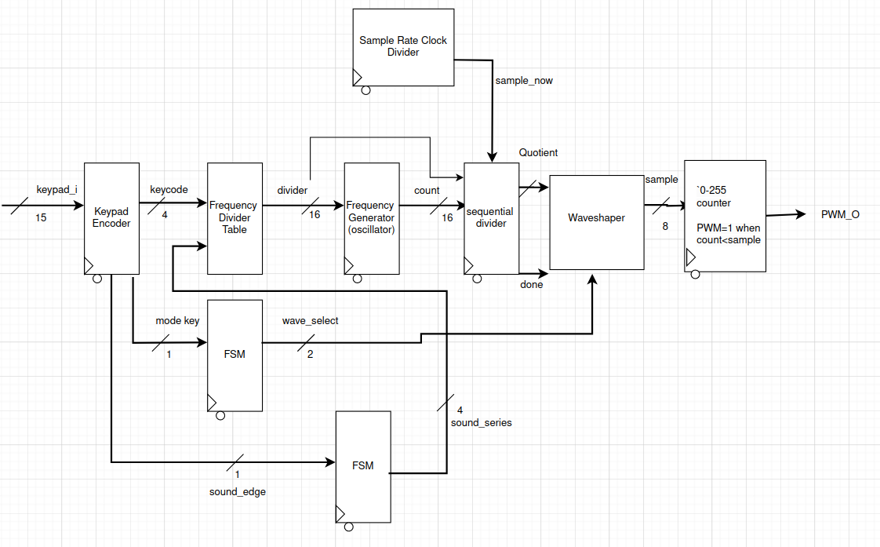

**Flow Chart: Top Level**

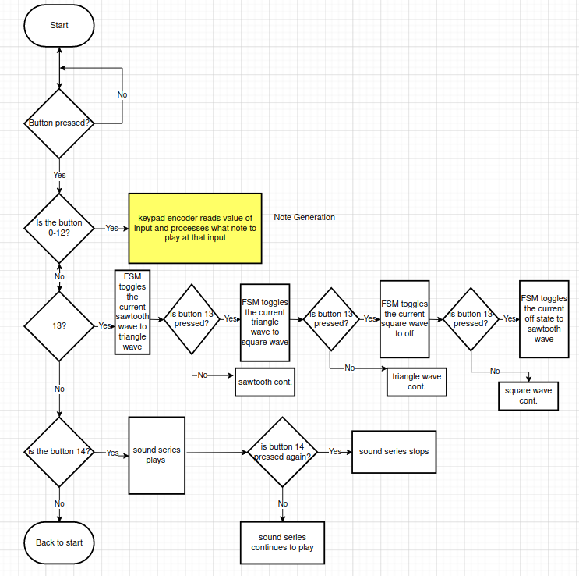

**Flow Chart: Sublevel**

